Moq
- Write testable Code with Moq:

CustomerCommLib / MailSender.cs

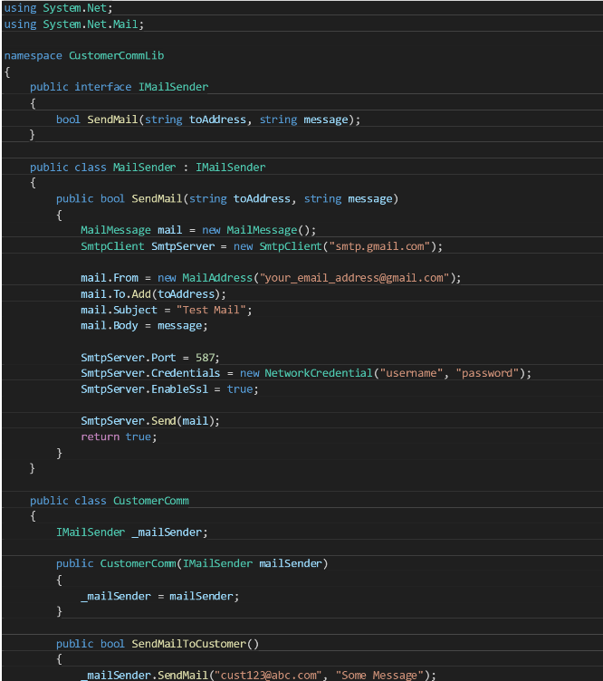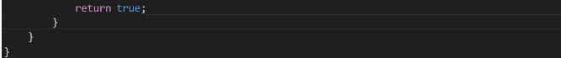

CustomerComm.Tests / CustomerCommTests.cs

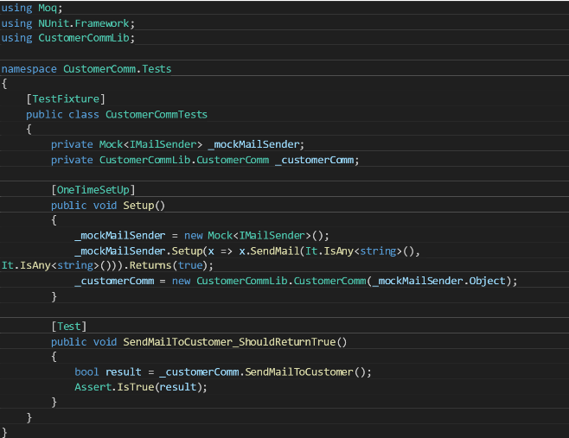

Output:

